**Project Development Phase**

**Sprint Delivery – I**

|  |  |
| --- | --- |
| **PROJECT TITLE** | **Gas Leakage Monitoring and Alerting System** |
| **TEAM ID** | **PNT2022TMID06977** |

**Introduction:**

In this Sprint Delivery -1, We have completed the hardware connections with the Arduino using the Tinkercad tool and used the Gas sensor to detect the gas. Once the gas is detected or sensed the light and the alarm goes on when some threshold value (a level that is harmful to humans) is reached. The value is shown in the LCD monitor which can be monitored at a certain period.

**USER STORY/TASK 1: Study of Gas Sensor**

**Gas Sensor:**

A gas sensor is a device that detects the presence or concentration of gases in the atmosphere. Based on the concentration of the gas the sensor produces a corresponding potential difference by changing the resistance of the material inside the sensor, which can be measured as output voltage. Based on this voltage value the type and concentration of the gas can be estimated.



Gas Sensor

The type of gas the sensor could detect depends on the sensing material present inside the sensor. Normally these sensors are available as modules with comparators as shown above. These comparators can be set for a particular threshold value of gas concentration. When the concentration of the gas exceeds this threshold, the digital pin goes high. The analog pin can be used to measure the attention of the gas.

**USER STORY/TASK 2: Connection of the Gas Sensor With Arduino**

**Hardware Connections:**

* A2 pin of the gas sensor is connected to the A0 analog of the Arduino that is used to get the gas sensor reading
* H1 pin is grounded
* A1 pin is grounded with the resistor of 4 kilo Ohm
* B1, B2 and H2 is connected to 5V Vcc of Arduino

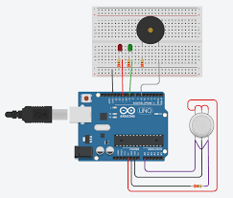

Connecting Arduino with Gas Sensor

**USER STORY/TASK 3: Connection of LCD Screen With Arduino**

**Hardware Connections:**

* Gnd of LCD is connected to Gnd of Arduino
* Vcc of LCD is connected to Vcc (5v) of Arduino
* V0 , RW is grounded
* RS is connected to the D12 (digital Pin) of Arduino
* DB4 is connected to D5 of Arduino
* DB5 is connected to D4 of Arduino
* DB6 is connected to D3 of Arduino
* DB7 is connected to D2 of Arduino
* LED pin is connected to Vcc (5V) of Arduino
* LED cathode is Grounded with 220-ohm resistor

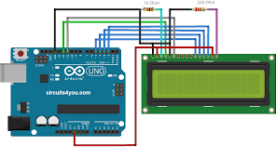

Connecting Arduino with LCD Display

**USER STORY/TASK 4 & 5: Connection of LED and Buzzer with Arduino for alarm**

**Hardware Connections:**

* Cathode of LED is grounded
* Anode of LED is connected to D9
* Cathode of Buzzer is grounded
* Anode of Buzzer is connected to D8

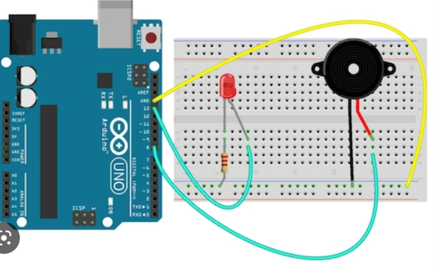

Connecting with LED and Buzzer with Arduino

**Final Arduino Code of Sprint 1:**

#include<LiquidCrystal.h>

int gasReading = 0;

int LED = 9;

int Buzzer = 8;

int gasSensor = A0;

int flag = 1;

LiquidCrystal lcd(12, 11, 5, 4, 3, 2);

void setup() {

lcd.begin(16, 2);

pinMode(LED, OUTPUT);

pinMode(Buzzer, OUTPUT);

pinMode(gasSensor, INPUT);

}

void loop() {

gasReading = analogRead(gasSensor);

String p = "Gas"+gasReading;

lcd.setCursor(0,0);

lcd.print(String("Sensor value:")+String(gasReading)); if(gasReading>400){

if(flag == 0) {

lcd.setCursor(0,1);

lcd.print(" ");

}

flag=1;

lcd.setCursor(0,1);

lcd.print("Gas Detected");

digitalWrite(LED, HIGH);

digitalWrite(Buzzer, HIGH);

}else {

if(flag == 1) {

lcd.setCursor(0,1);

lcd.print(" ");

}

flag=0;

lcd.setCursor(0,1);

lcd.print("No Gas Detected");

digitalWrite(LED, LOW);

digitalWrite(Buzzer, LOW);

}

delay(500);

}

**Final Hardware Connection of Sprint 1:**

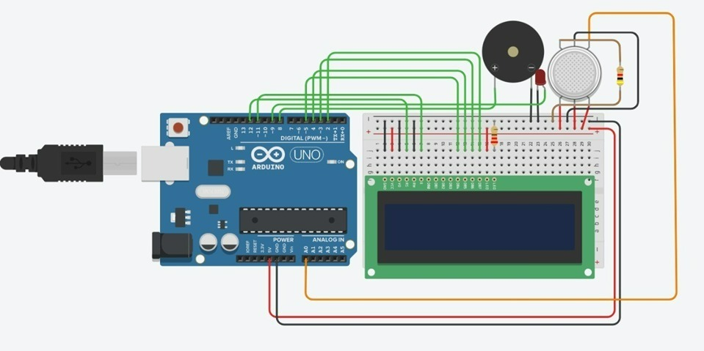

Final Arduino Connection

**Output of Arduino Simulation:**

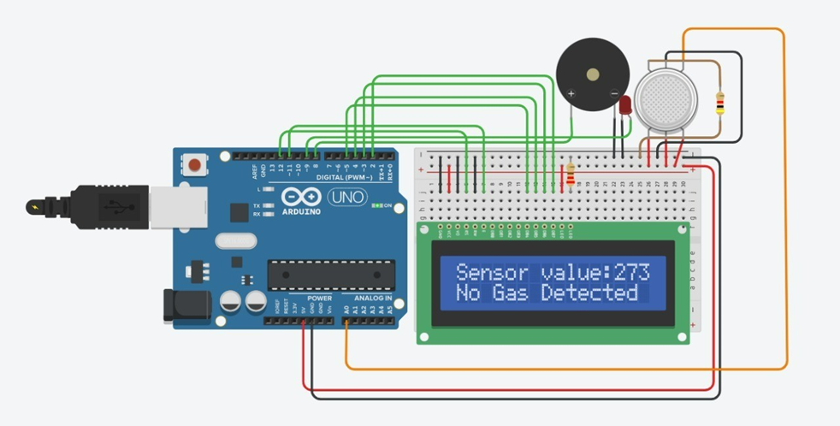

Output Reading when there is no Gas Leakage

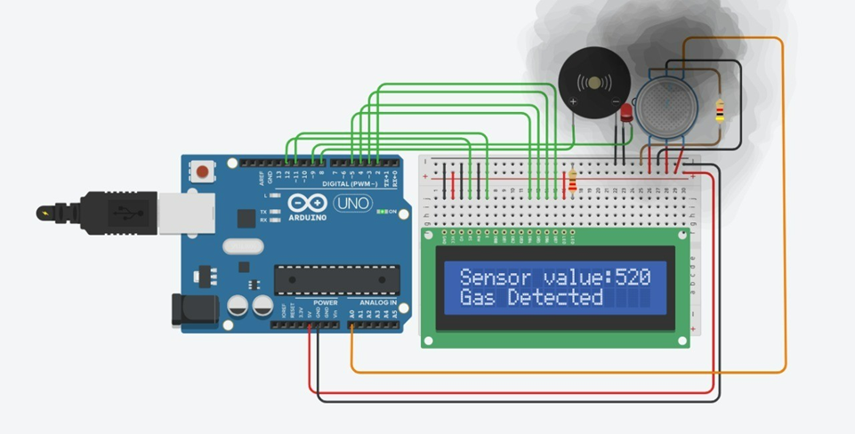

Output Reading when there is Gas Leakage

**Project Link:**

Link for the Hardware in TinkerCAD: <https://www.tinkercad.com/things/67GXRIshYdg>

**Demo Link:**

Link for the Demo video of Project:

<https://drive.google.com/drive/folders/1ZesOrCqdZJQKc8DVe00X15nj0hnsbTc_?usp=sharing>